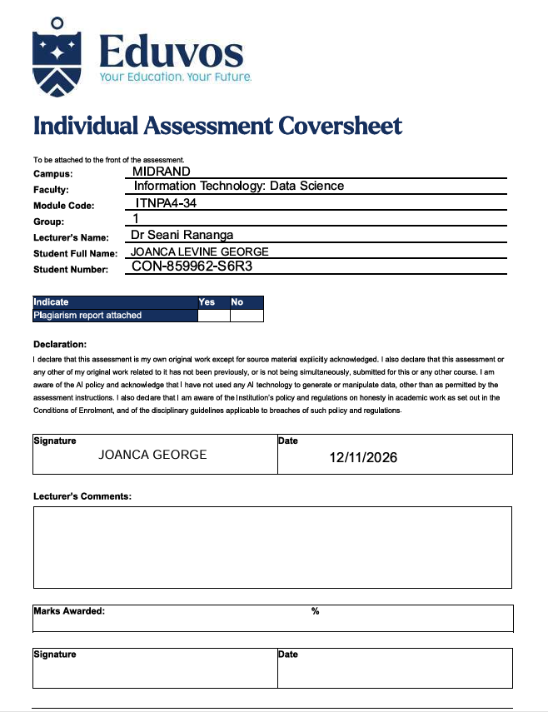

ITNPA4-34
PROJECT 1
MIDRAND
CON-859962-S6R3

TABLE OF CONTENTS
QUESTION 1 4
QUESTION 2 16
QUESTION 3 28
QUESTION 4 35
REFERENCES 40

QUESTION 1

  - First, I imported all the libraries I would be using as shown in the screenshot below:

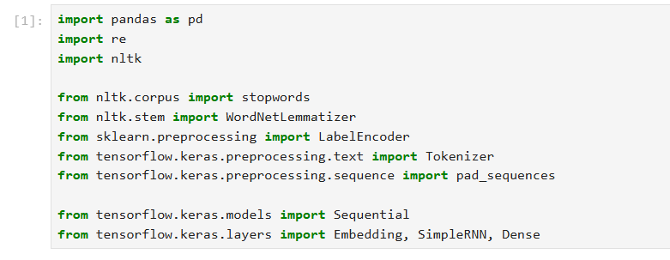

I then loaded the file into the ide, as a dataset using pandas. I printed the dataset to gain a better understanding of the content of the dataset as well, as shown in the screenshot below:
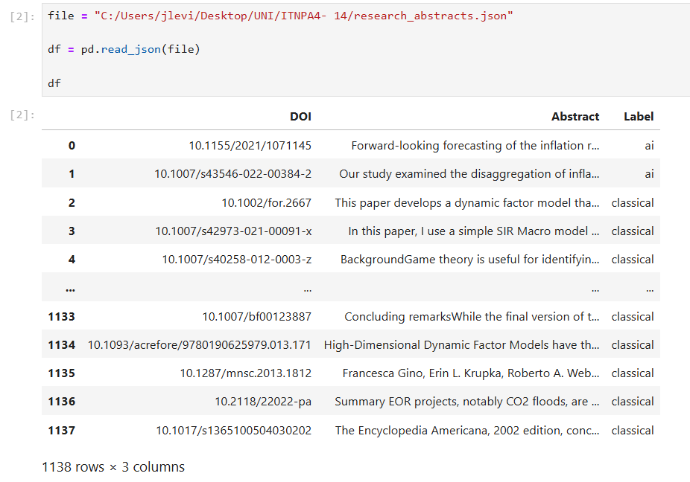

I then checked for duplicated entries as part of the preprocessing, and removed the duplicated entries:
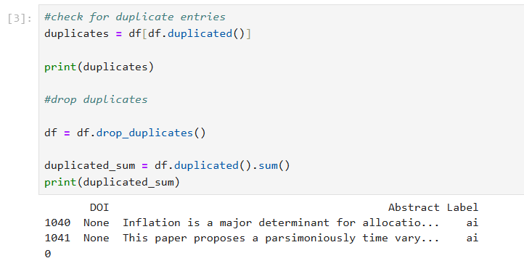

After that I also checked for any missing values and removed those from the dataset as well:
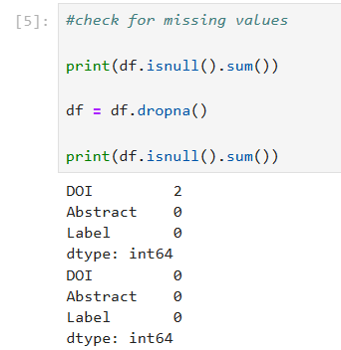

Because we will be using the abstract information to understand the categories of the information, the DOI column was unnecessary, therefore I dropped it from the dataset:
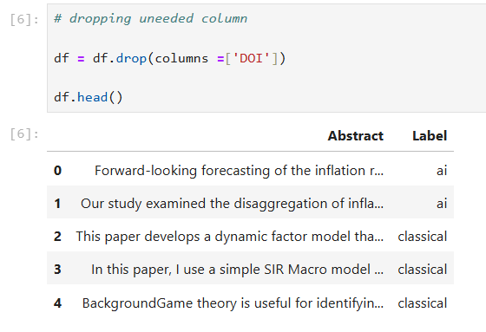

I also made all the abstract column information lowercase and removed all the punctuation so that the information being processed is only the relevant information. Lowercasing the information makes the words less complex and improves the accuracy pf NLP models. (Mousavi, 2025). Removing punctuation reduces noise and helps with tokenization as well. (Mousavi, 2025) :

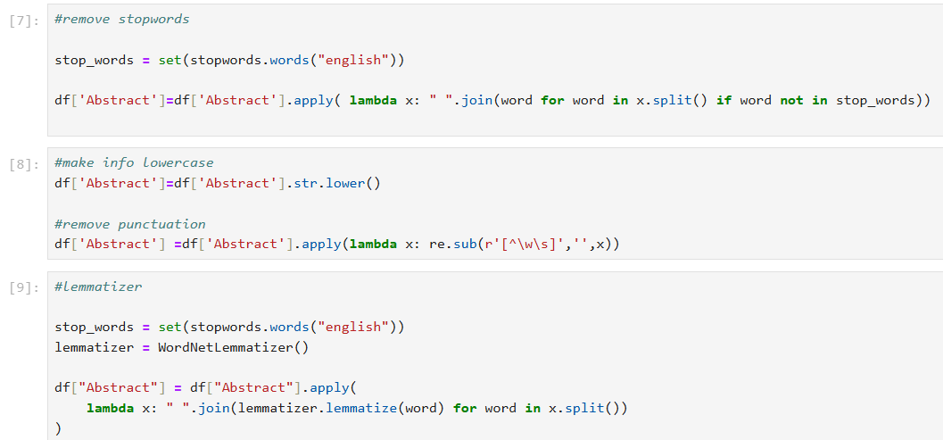

Continuing with preprocessing I then removed the stop words. Stop words are commonly used words in a language that have no meaning or use when analysing textual information. Therefore, these words are removed as doing so improves efficiency and model performance (geeksforgeeks, 2026):

As part of preprocessing, I also performed lemmatization. This is a technique that breaks words down to their root word, which give the programs less raw data to learn (Coursera staff, 2026):

  - For feature engineering (Databricks Staff, 2024) I made the abstract column the feature column as this column contains all the information required for the model to make the decisions, and the answers are in the target column (label column) .
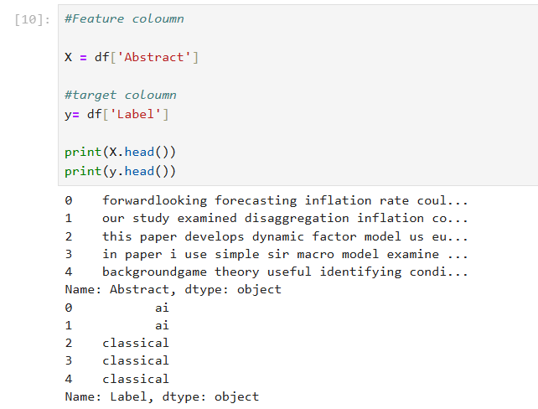

  - The RNN model (aws, n.d.) was used because it is a NLP learning model which will be able to categorize the information into certain groups; hence it is the most suitable.

The tokenizer (Kashyap, 2024) was used to change words into numerical values based on the text and then each abstract is converted into a sequence of numerical values to be used in the RNN model

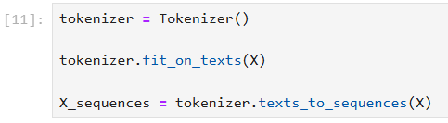

I then made all the text sequences the same length by adding padding where it was needed so that the sequences have a consistent format that can be processed by the RNN.

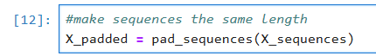

I used label encoder to convert the text into numerical values so the model can process the information.
I then trained and split the data into 80% training data and 20% testing data to train and evaluate the model

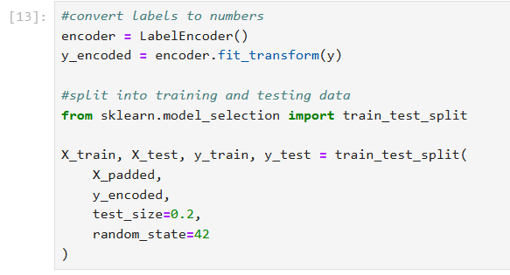

I added an embedding layer to convert the numerical word sequences into vector representations and the RNN learns patterns and relationships in the text.
The next layer used sigmoid function to classify each one into one of two categories: ai or classical

After that the model was compiled using the Adam optimiser and binary cross entropy loss function to learn the two-class classification problem. The model is then trained for 10 epochs using the training data while the test data is used to monitor performance during training.
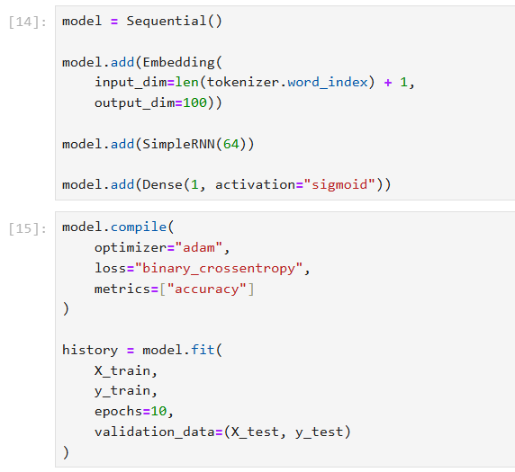

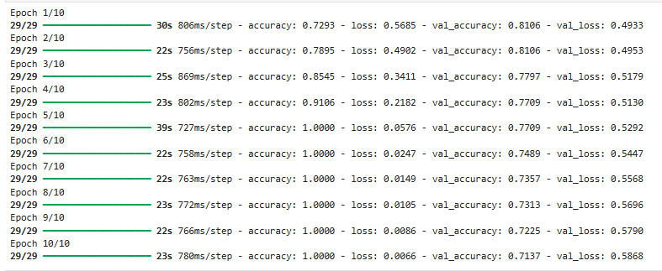

I then ran an accuracy test, and from the results shown below, the model performed correctly 71.36% of the time. This shows that the model successfully learned patterns from training data, but the difference between training and testing accuracy suggest overfitting which is when the model performs well on training data but not as well on testing data (aws, n.d.).
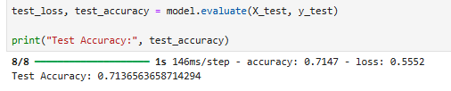

I also used a confusion matrix to compare the actual categories with the categories predicted by the model.

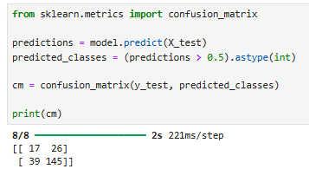

This means that the model performed better at identifying class 1 than class 0.

Full code:
import pandas as pd
import re
import nltk

from nltk.corpus import stopwords
from nltk.stem import WordNetLemmatizer
from sklearn.preprocessing import LabelEncoder
from tensorflow.keras.preprocessing.text import Tokenizer
from tensorflow.keras.preprocessing.sequence import pad_sequences

from tensorflow.keras.models import Sequential
from tensorflow.keras.layers import Embedding, SimpleRNN, Dense

file = "C:/Users/jlevi/Desktop/UNI/ITNPA4- 14/research_abstracts.json"
df = pd.read_json(file)
df

#check for duplicate entries
duplicates = df[df.duplicated()]

print(duplicates)

#drop duplicates

df = df.drop_duplicates()

duplicated_sum = df.duplicated().sum()
print(duplicated_sum)

#check for missing values

print(df.isnull().sum())

df = df.dropna()

print(df.isnull().sum())

# dropping uneeded column

df = df.drop(columns =['DOI'])

df.head()
#remove stopwords

stop_words = set(stopwords.words("english"))

df['Abstract']=df['Abstract'].apply( lambda x: " ".join(word for word in x.split() if word not in stop_words))
#make info lowercase
df['Abstract']=df['Abstract'].str.lower()

#remove punctuation
df['Abstract'] =df['Abstract'].apply(lambda x: re.sub(r'[^\w\s]','',x))
#lemmatizer

stop_words = set(stopwords.words("english"))
lemmatizer = WordNetLemmatizer()

df["Abstract"] = df["Abstract"].apply(
lambda x: " ".join(lemmatizer.lemmatize(word) for word in x.split())
)

#Feature coloumn

X = df['Abstract']

#target coloumn
y= df['Label']

print(X.head())
print(y.head())
tokenizer = Tokenizer()

tokenizer.fit_on_texts(X)

X_sequences = tokenizer.texts_to_sequences(X)
#make sequences the same length
X_padded = pad_sequences(X_sequences)
#convert labels to numbers
encoder = LabelEncoder()
y_encoded = encoder.fit_transform(y)

#split into training and testing data
from sklearn.model_selection import train_test_split

X_train, X_test, y_train, y_test = train_test_split(
X_padded,
y_encoded,
test_size=0.2,
random_state=42
)
model = Sequential()

model.add(Embedding(
input_dim=len(tokenizer.word_index) + 1,
output_dim=100))

model.add(SimpleRNN(64))

model.add(Dense(1, activation="sigmoid"))
model.compile(
optimizer="adam",
loss="binary_crossentropy",
metrics=["accuracy"]
)

history = model.fit(
X_train,
y_train,
epochs=10,
validation_data=(X_test, y_test)
)
test_loss, test_accuracy = model.evaluate(X_test, y_test)

print("Test Accuracy:", test_accuracy)
from sklearn.metrics import confusion_matrix

predictions = model.predict(X_test)
predicted_classes = (predictions > 0.5).astype(int)

cm = confusion_matrix(y_test, predicted_classes)

print(cm)

QUESTION 2

2.1) The machine learning models I’ve chosen is Logistic regression, Support Vector Machines, Long Short-Term Memory, and Bidirectional Long Short-Term Memory.

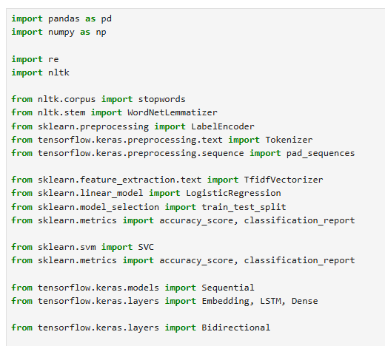

I first imported the needed libraries I would be using for the models I will be training.
And loaded my file into my IDE.
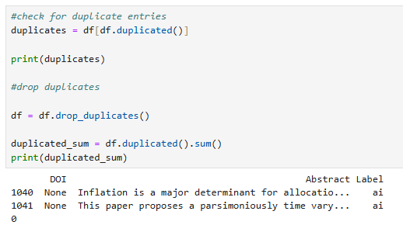

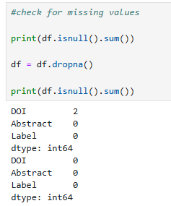
I then cleaned the data by dropping duplicates and removing missing values from the data.

I also removed the unneeded column from the dataset:
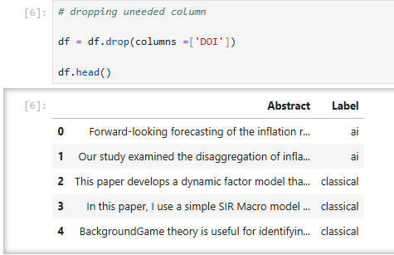

I also pre-processed the data by removing common English words (Shishiradhikari, 2025), converting to lowercase and removed punctuation to reduce unneeded information.
Lemmatization was used to change the words to their base form (Divya Khyani, 2021) and the abstracts were tokenised and converted into numerical values .

For the Logistic Regression and SVM models, Term Frequency-Inverse Document Frequency (geeks for geeks, 2025) was used, but tokenisation and padding was used for the LSTM and Bi-LSTM models. Padding was also added to make all the sequences the same length.
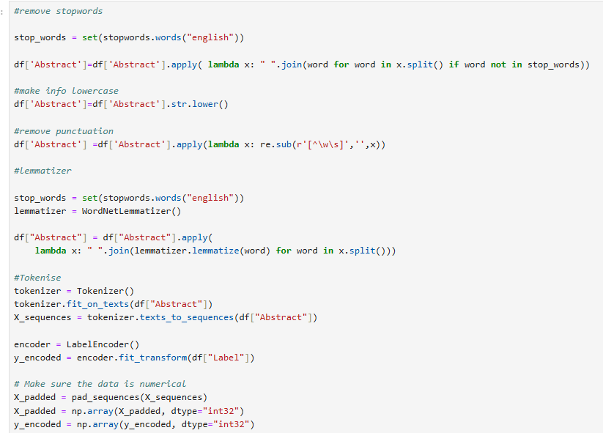

I then split the data and I used Term Frequency-Inverse Document Frequency to turn text into numbers because machine learning models can only work with numerical values. (geeks for geeks, 2025).

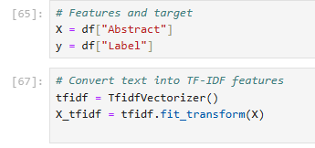

I used TF-IDF for the logistic regression model and SVM model.

LOGISTIC REGRESSION:

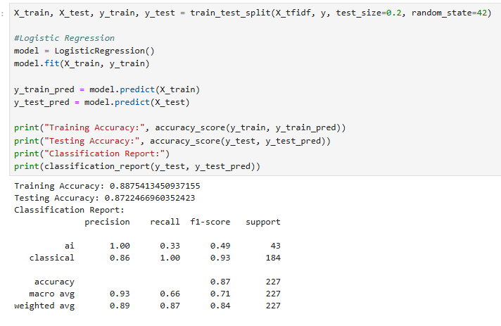

I then trained and fit the logistic regression model (Geeks for Geeks, 2026) To understand the performance of the model I checked it’s accuracy score (Machine Learning, 2024) and a classification report (dataXmlchronicle, 2025)

As shown, the model got a testing accuracy of 87.22% which means, the model correctly classified 87% of the data.
These results are higher than the baseline RNN testing accuracy of 71.36%, which means that the Logistic Regression model performed better than the baseline model.

SVM:
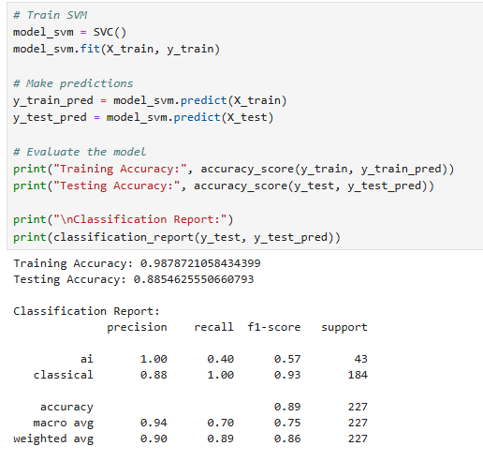

As shown in the screenshot above, the SVM model (Kavlakoglu, 2023) had a test accuracy of 88.54%, meaning that it correctly classified 88% of the test data to their categories.

The accuracy results were better than the baseline RNN model, meaning it performs better than the RNN model. The SVM also performed slightly better than Logistic Regression in terms of testing accuracy.

Long Short-Term Memory:
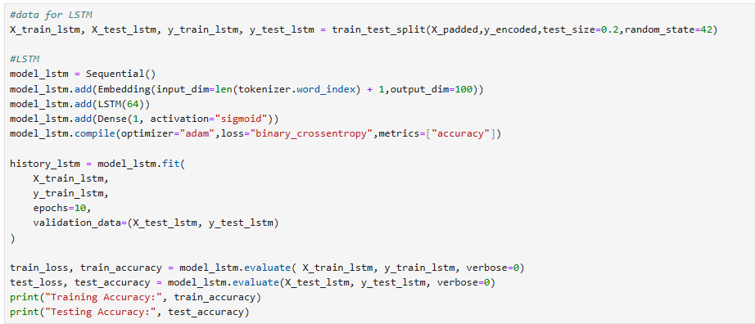

As shown above I trained and fitted the LSTM model (geeks for geeks, 2026).
However, for the LSTM model I had to split the data separately because the LSTM uses a different form of input data, while the other models used the TF-IDF, the LSTM uses padded word sequences.
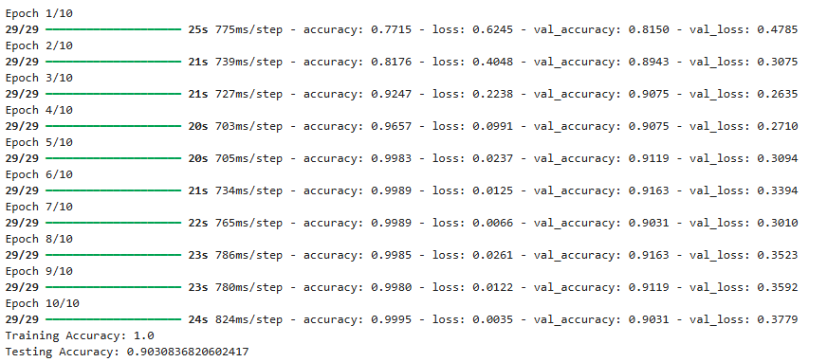

As shown from the results above, the LSTM achieved a testing accuracy of 90.30%, which means that the model correctly classified 90% of the unseen data. The training accuracy is higher than the testing accuracy which suggests overfitting. However, the testing accuracy was higher than the RNN model accuracy value.
From the results we see that the LSTM model got the highest testing accuracy of the four models so far.

Bi-LSTM:
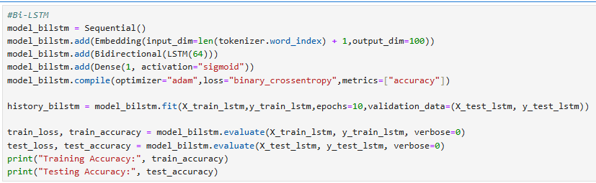

As shown above, I fitted and trained the Bi-LSTM model (Anishnama, 2023).
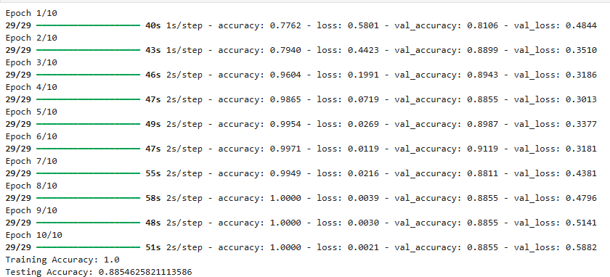

This model got a testing accuracy of 88.5% which means that the model correctly classified 88% of the unseen data, however there could be overfitting, as the testing score is lower than the training score.
The testing accuracy was higher than the RNN model accuracy but lower than the LSTM model's accuracy.

Overall, the LSTM performed the best out of the four models, as it achieved a testing accuracy of 90.30%. This was followed by SVM and Bi-LSTM, both achieving 88%, and Logistic Regression achieving 87%. All four models achieved higher testing accuracy than the baseline RNN model, which achieved 71.36%.

2.2) For the enhancement I chose to use a dropout technique to improve the LSTM performance.
The dropout technique is used to reduced overfitting as it randomly ignored proportion of neurons so that the model does not rely too much on specific neurons. (TensorFlow Core, n.d.)

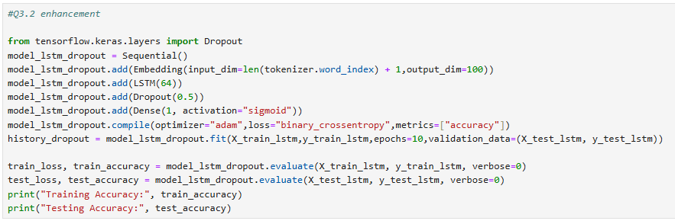

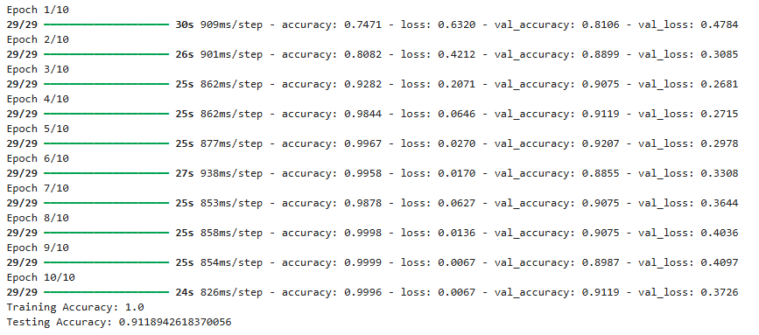

As shown above a dropout was used with the rate of 0.5 on the LSTM model because the LSTM model showed to have potentially overfitted.
After adding the dropout, the LSTM results improved to 91.18%, which shows that the technique worked slightly but not enough to reduce overfitting.

2.3)
In order to create the web interface, I will be using streamlit which is a framework that is used in python to build web applications. (geeksforgeeks, 2026)
I imported the needed libraires as well, like re, stopwords, and lemmatizer, which is used for text cleaning, so that regardless of what the user puts into the abstract box the text is simplified for the machine to understand it better and categorise the information.

As shown, I loaded the trained LSTM model and the saved files to process the abstract. I used a tokenizer and encoder as well. I then created a function which allowed all the text cleaning steps to happen. The reason for this is so that the user’s abstract is in the same format as the data that was used to train the model in the first place.

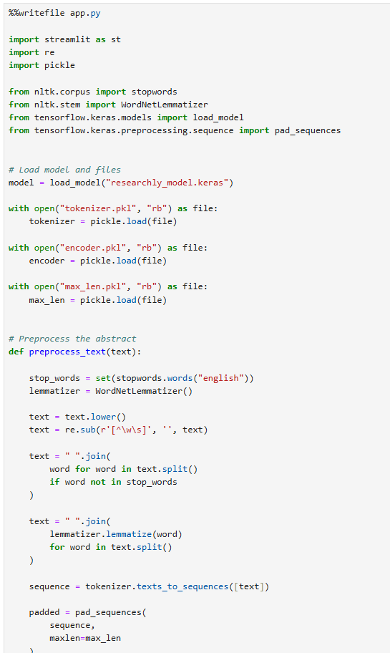
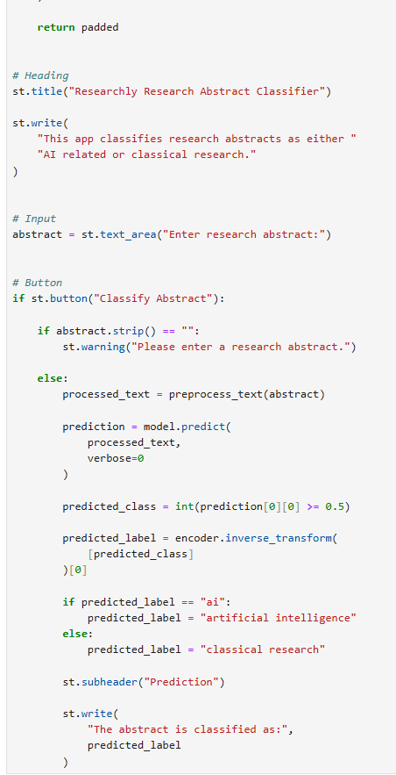
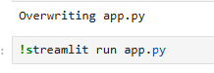
As shown in the screenshots above here I created the interface of the web application. This is what the user interacts with in order to find the category the text given falls into, either AI research or classical research.
The last cell starts the Streamlit application. I made the command to run directly from the Jupyter Notebook environment.

The screenshots bellow shows the application:

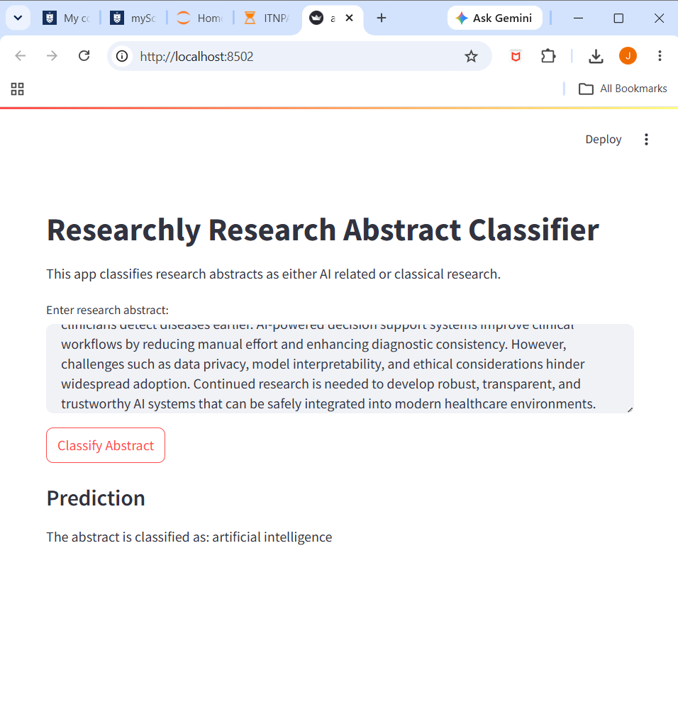

QUESTION 3

3.1)
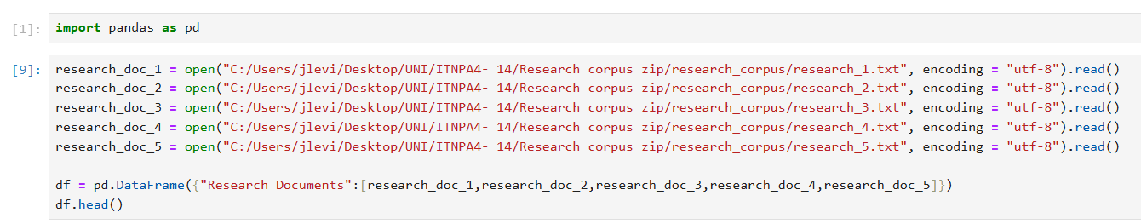

As shown in the screenshot above I first imported the panda’s library and then loaded each article.
I then used the panda’s ability to put all the research documents into one data frame :
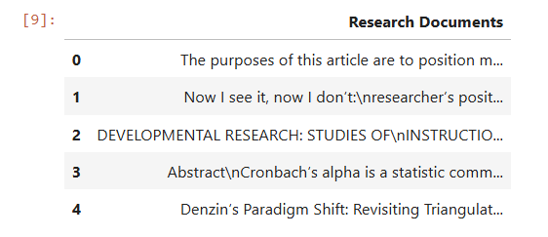

3.2)
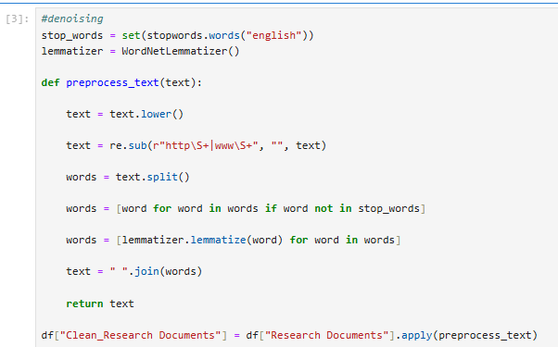

As shown in the screenshot above for denoising techniques I created a function whereby I ensured that the text is in lowercase, I removed punctuation, performed stop word removal and used a Lemmatizer in order for the text to be pre-processed so that the model would be able to understand the text enough to categorise the information.

3.3)
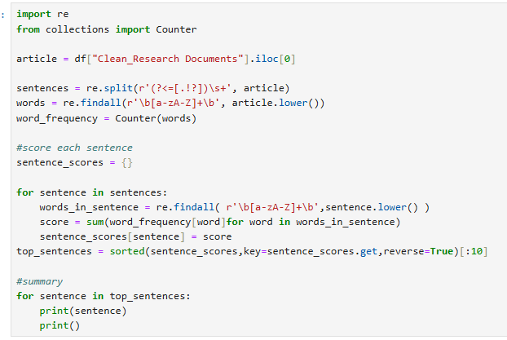

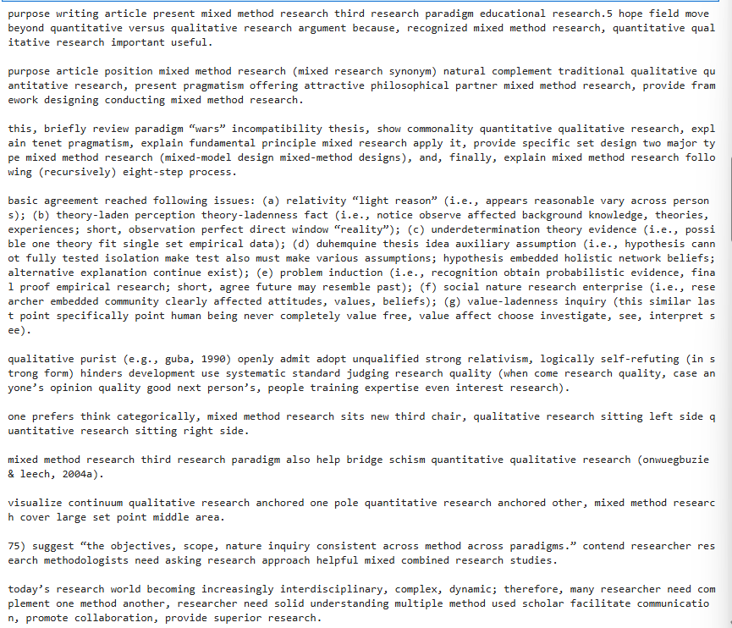

A frequency-based summarisation technique was used to produce an aggregate summary of the research article.
The text that was pre-processed was used and each sentence was scored according to frequency, with words that appear more often receiving higher scores.
The sentences that had the highest scores were selected for the summary. Since the denoising process removed stopwords and punctuation, the summary contains simplified sentence structures. This approach was used to identify the main themes in the research article.

Visualisation:
For the visualisation I created a bar graph to show the frequency count of the top 10 most frequent words. However, these frequent words do not necessarily represent the topics identified by LSA on their own.

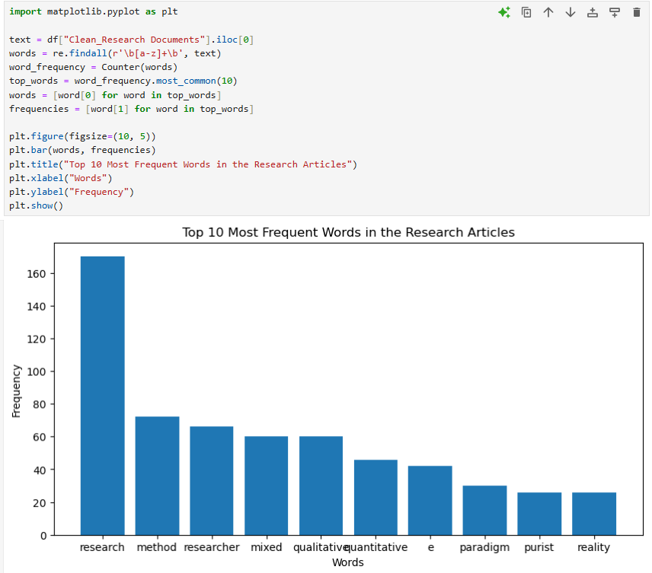

3.4) For the remaining articles I used Latent Semantic Analysis (geeks for geeks, 2026) to create an aggregate summary of the articles. The articles were split in sentences. Short sentences and citation-heavy fragments were removed. The CountVectorizer converted the sentences into numerical forms and the SVD (Ahn, 2024) was used to identify underlying patterns. The sentences were then scored and ranked as top 10, for the summary. This helped identify important information across the remaining research articles.
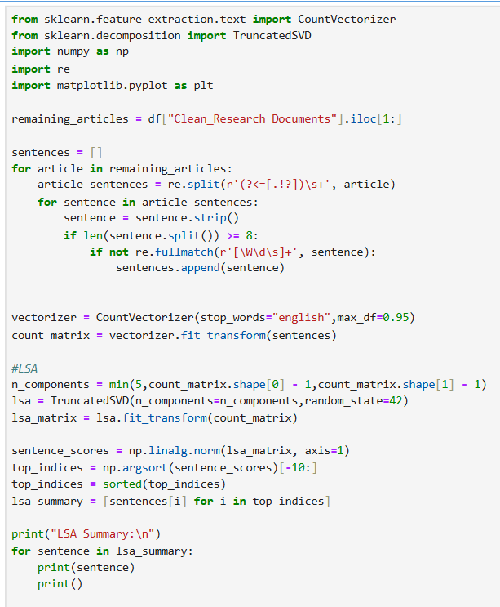
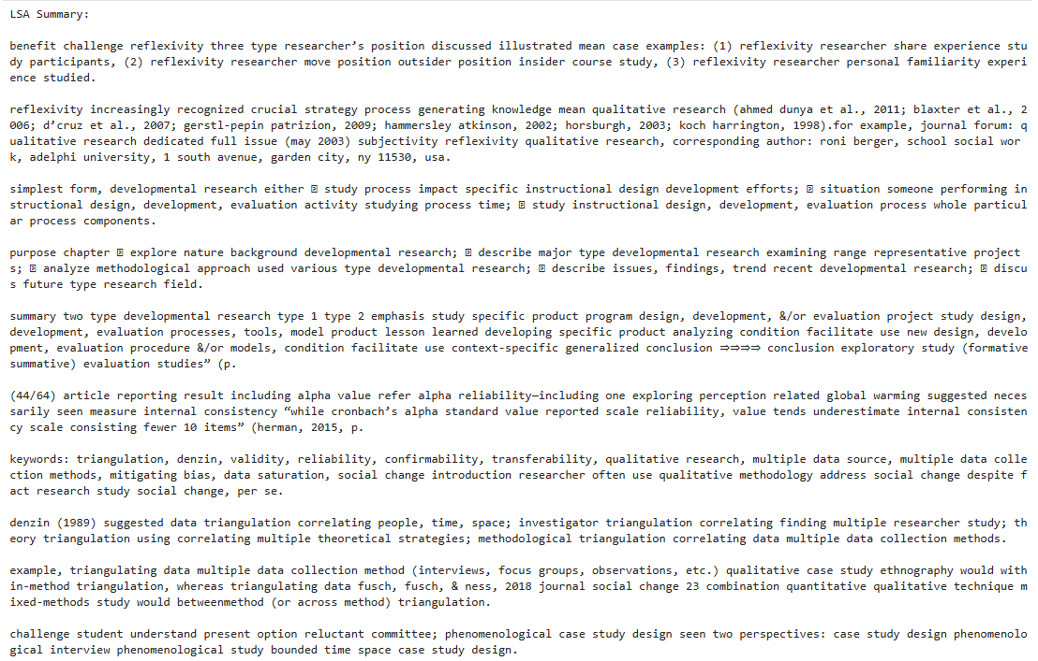

Visualisation:
For visualisation I combined the text from the articles and found the words that appeared the most. After filtering the words with at least 3 letters, I calculated their frequencies and put the top 10 words in a bar graph. From the results we see that research, study, alpha and data appear the most across the articles which suggest the main themes of the articles.
The graph provides an overview of the most frequently used words, helping to highlight common terms across the articles. However, these frequent words do not necessarily represent the topics identified by LSA on their own.

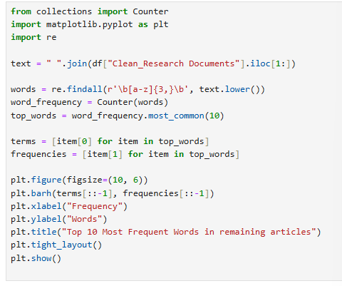

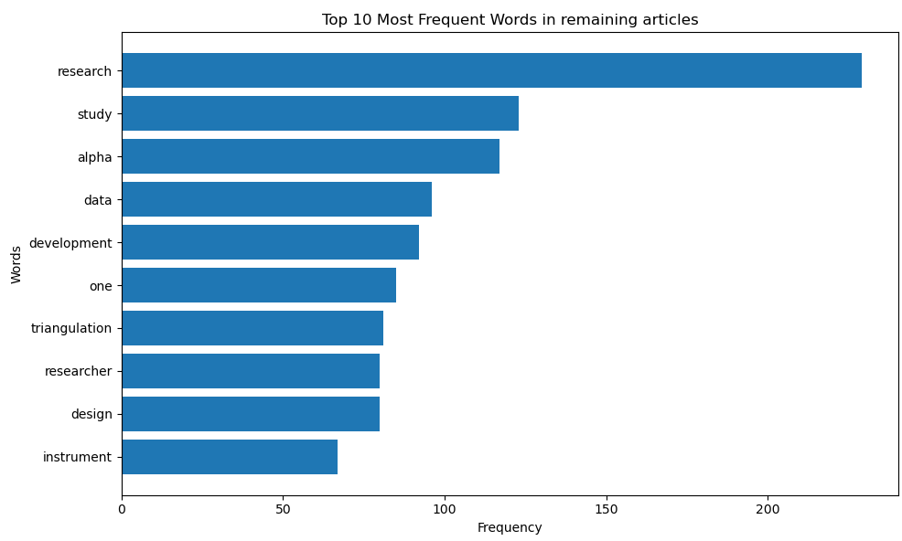
Figure 1: Bar graph (Domo, 2025)

QUESTION 4

4.1) As shown in the screenshots bellow, I applied the Latent Dirichlet Allocation (David M. Blei, 2003) to the documents. I converted the text into a matrix using the count vectorizer (Nigam, 2025) then fit the LDA model with 5 topics. I then extracted and printed the top 10 words for each topic to help me understand the main themes in the topics.

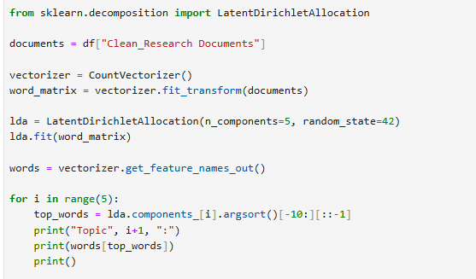

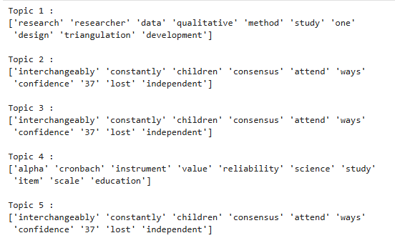

I used the fitted LDA model to compute the topic distribution (Mukherjee, 2026) for each document, which returns the probability that each document belongs to each of the five topics. To understand, I put the distributions of the topics into a data frame

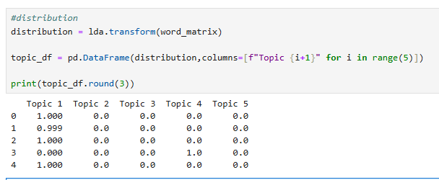

I then visualised the topics into a bar graph (Plotly, n.d.) according to their distribution values:
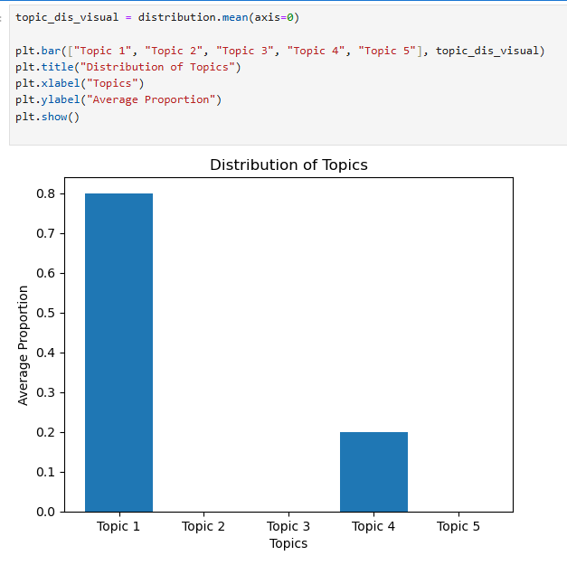

As shown from the graph above the topic distribution shows that topic 1 is the dominant theme, with a split in the topic distribution between Topic 1 and Topic 4, at 80% and 20% respectively. The remaining topics have almost no representation in the documents. This suggests that there are two themes in the documents that are different to one another.

4.2) The pyLDAvis (pyLDAvis, n.d.) showed me the top 30 of my salient words with the top 6 being research, researcher, method, data, alpha and qualitative, across the research corpus. This suggests that research and data analysis is likely a main theme in the documents. The salient words provide an overview of the main terms used in the corpus. (Paola Merlo, 2003)
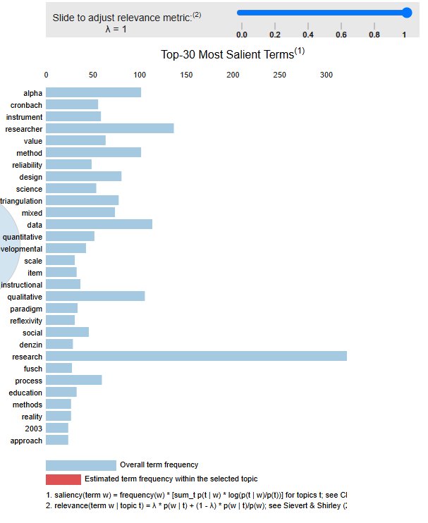

When I focused on topic 1 the visualisation showed the following:

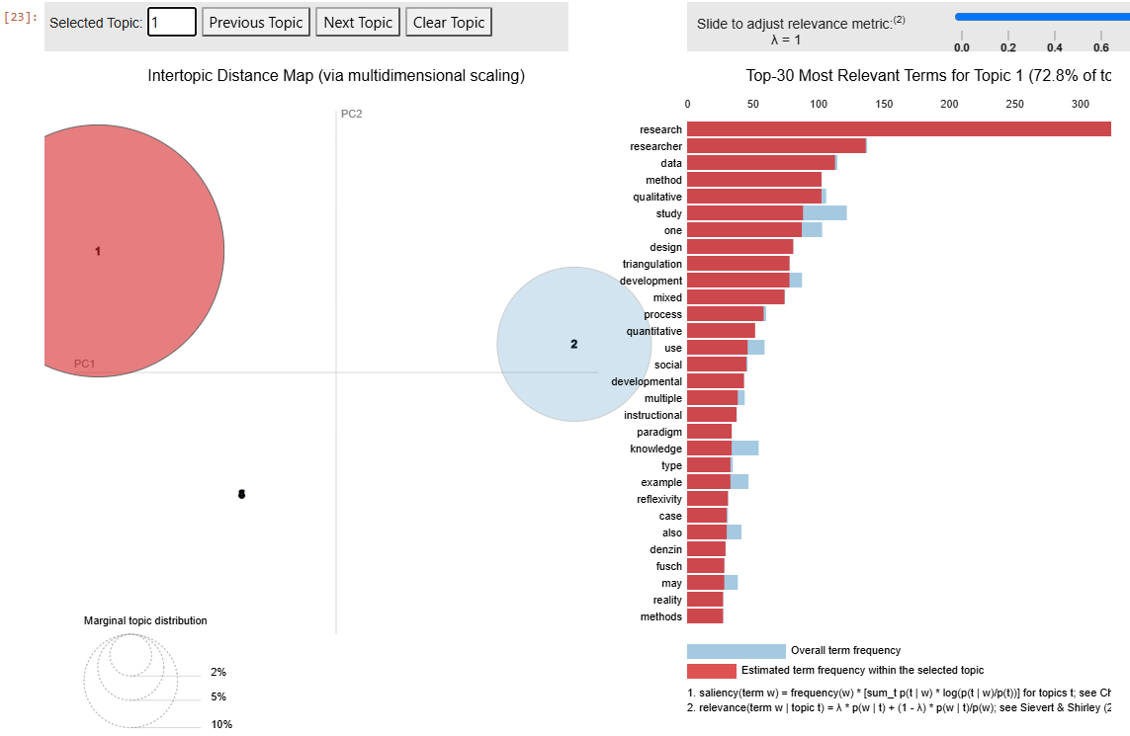

As shown above topic 1 had 72.8% of tokens on research methodology, using a lot of the following terms: research, data, and quantitative. This suggests that Topic 1 mainly focuses on research methodologies and quantitative data analysis.

When I focused on topic 2 this is what I saw:
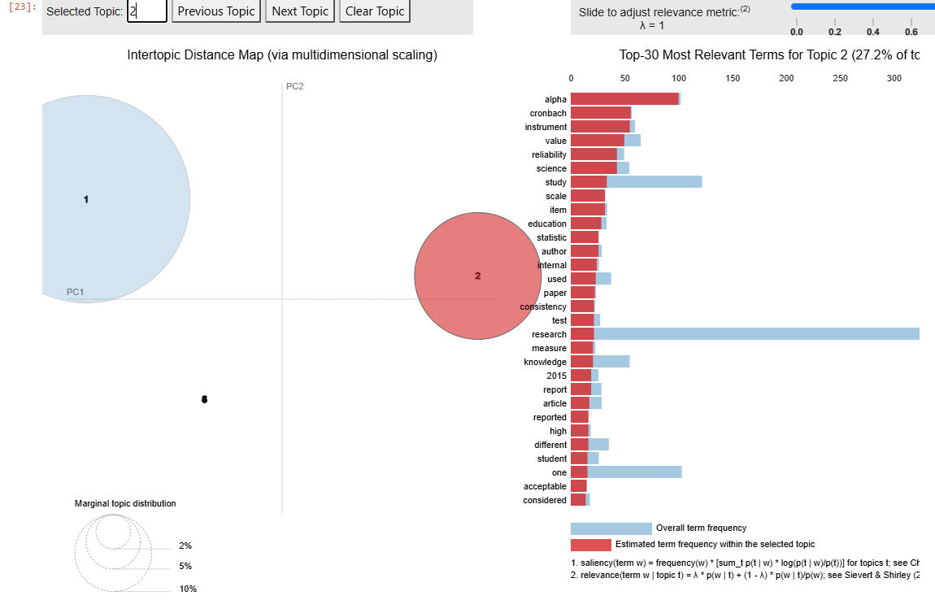

As shown in the screenshot above topic 2 has 27.2% of the tokens and used terms like alpha, Cronbach and instrument, suggesting topic 2 focuses on things like instrument reliability and measurement.

In conclusion the distance between the two topics is large indicating that the documents have 2 different themes.
The remaining topics were almost irrelevant in size and overlapped on the map suggesting that the two topics are enough to describe the corpus.

REFERENCES
Ahn, S., 2024. Medium. [Online]
Available at: https://medium.com/@sahn1998/singular-value-decomposition-svd-in-data-science-37e28aa7828f
Anishnama, 2023. Medium. [Online]
Available at: https://medium.com/@anishnama20/understanding-bidirectional-lstm-for-sequential-data-processing-b83d6283befc
aws, n.d. aws. [Online]
Available at: https://aws.amazon.com/what-is/recurrent-neural-network/
aws, n.d. aws. [Online]
Available at: https://aws.amazon.com/what-is/overfitting/
Coursera staff, 2026. Coursera. [Online]
Available at: https://www.coursera.org/articles/what-is-lemmatization
Databricks Staff, 2024. Databricks. [Online]
Available at: https://www.databricks.com/blog/what-is-feature-engineering
dataXmlchronicle, 2025. Medium. [Online]
Available at: https://medium.com/@dataXmlchronicle/mastering-the-concept-of-classification-report-in-machine-learning-514e69eac24c
David M. Blei, A. Y. N. M. I. J., 2003. Latent Dirichlet Allocation. Journal of Machine Learning Research 3.
Divya Khyani, S. B. N. N. D. B. M. Y., 2021. An Interpretation of Lemmatization and Stemming in Natural Language Processing. Journal of University of Shanghai for Science and Technology.
Domo, 2025. Progress Domo. [Online]
Available at: https://www.domo.com/learn/charts/horizontal-bar-graph
geeks for geeks, 2025. geeks for geeks. [Online]
Available at: https://www.geeksforgeeks.org/nlp/text-summarization-techniques/
geeks for geeks, 2026. geeks for geeks. [Online]
Available at: https://www.geeksforgeeks.org/machine-learning/latent-semantic-analysis/
geeks for geeks, 2026. geeks for geeks. [Online]
Available at: https://www.geeksforgeeks.org/deep-learning/deep-learning-introduction-to-long-short-term-memory/
Geeks for Geeks, 2026. Geeks for Geeks. [Online]
Available at: https://www.geeksforgeeks.org/machine-learning/understanding-logistic-regression/
geeksforgeeks, 2026. geeksforgeeks. [Online]
Available at: https://www.geeksforgeeks.org/nlp/removing-stop-words-nltk-python/
geeksforgeeks, 2026. geeksforgeeks. [Online]
Available at: https://www.geeksforgeeks.org/python/a-beginners-guide-to-streamlit/
Kashyap, P., 2024. Medium. [Online]
Available at: https://medium.com/@piyushkashyap045/understanding-tokenizers-in-natural-language-processing-nlp-1c295d3cfec2
Kavlakoglu, E., 2023. IBM. [Online]
Available at: https://www.ibm.com/think/topics/support-vector-machine
Machine Learning, 2024. Machine Learning.org.in. [Online]
Available at: https://machinelearning.org.in/accuracy-score/
Mousavi, E., 2025. Medium. [Online]
Available at: https://medium.com/@ebimsv/nlp-series-day-3-lowercasing-and-removing-punctuations-0703617cf7b6
Mukherjee, S., 2026. Digital Ocean. [Online]
Available at: https://www.digitalocean.com/community/tutorials/introduction-to-topic-modelling
Nigam, J., 2025. Medium. [Online]
Available at: https://medium.com/@jyotinigam2370/what-is-countvectorizer-961d37e9a290
Paola Merlo, J. H. G. S. E. W., 2003. Research Gate. Linguistik Online.
Plotly, n.d. Plotly. [Online]
Available at: https://plotly.com/python/bar-charts/
pyLDAvis, n.d. pyLDAvis 3.4.1. [Online]
Available at: https://pypi.org/project/pyLDAvis/
Shishiradhikari, 2025. Medium. [Online]
Available at: https://medium.com/@shishiradhikari444/a-simple-understanding-of-stopwords-in-nlp-dd24e36fd228
TensorFlow Core, n.d. TensorFlow. [Online]
Available at: https://www.tensorflow.org/tutorials/keras/overfit_and_underfit

